## Assignment # 1

Gavyn Gallagher

MSDS 460

Note: I also attached my python with the submission.

## Problem 1

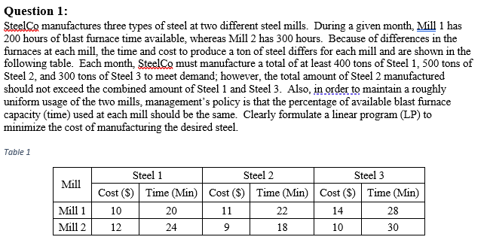

M = Mill, S = steel

Variables:

M1_S1

M1_S2

M1_S3

M2_S1

M2_S2

M2_S3

Constraints :

* M1_S1 + M2_S1 >= 400 # steel 1 units
* M1_S2 + M2_S2 >= 500 # steel 2 units
* M1_S3 + M2_S3 >= 300 # steel 3 units
* M1_S1*20 + M1_S2*22 + M1_S3*28 <= 200*60 # Mil 1 blast hours in minutes
* M2_S1*24 + M2_S2*18 + M2_S3*30 <= 300*60 # Mil 2 blast hours in minutes
* -(M1_S2 + M2_S2) - M1_S1 - M1_S3 - M2_S1 - M2_S3 <= 0
* (M1_S1*20/12000)+ (M1_S2*22/12000) + (M1_S3*28/12000) - (M1_S1*24/18000) - (M1_S2*18/18000) - (M1_S3*30/18000) <= 0
* All variables >= 0

Objective function :

M1_S1*10 + M1_S2*11 + M1_S3*14 + M2_S1*12 + M2_S2*9 + M2_S3*10

**Answer**:

* M1_S1 = 0.0
* M1_S2 = 0.0
* M1_S3 = 0.0
* M2_S1 = 400.0
* M2_S2 = 500.0
* M2_S3 = 300.0

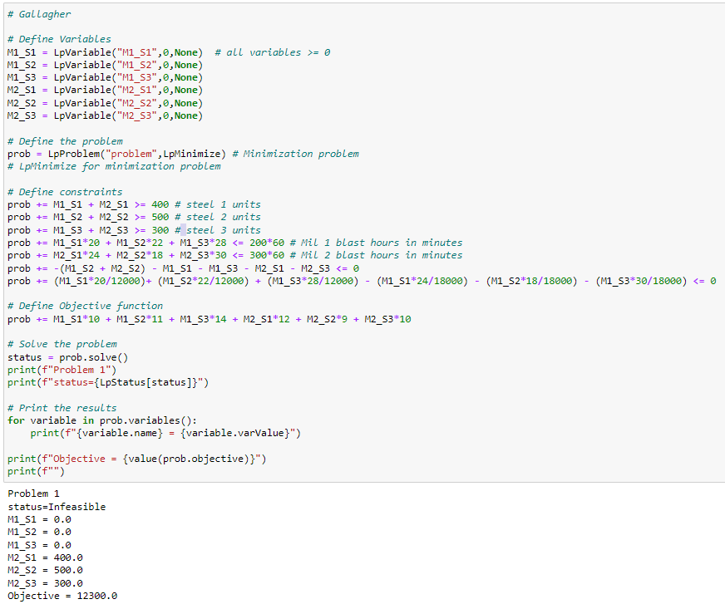

## Problem 2

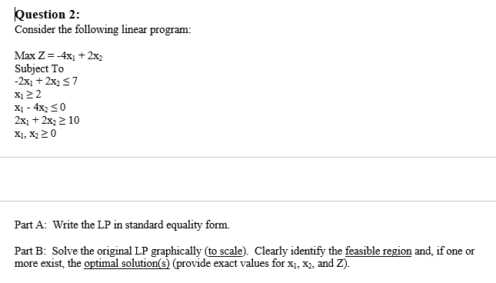

Part A:

Variables

X1, X2

Cosntraints:

-2X1 + 2X2 + S1 = 7

X1 + S2 = 2

X1- 4X2 + S3 = 0

2X1 + 2X2 + S4 = 10

X1, X2 >= 0

Objective Fucntions:

Z = -4*X1 + 2*X2 # Maximization problem

Part B:

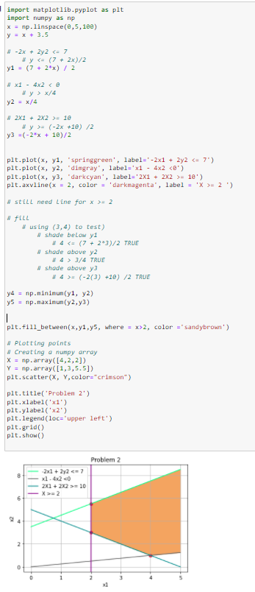

Note: I used the point (3,4) to test wheter to shade above or below each constraint line. The sandy brown color is the feasible region in the graph above. There is no border blocking it to the right and it will extend forever.

**Answer**: unbounded solution. Meaning infinite solutions and no optimal solution.

## Problem 3

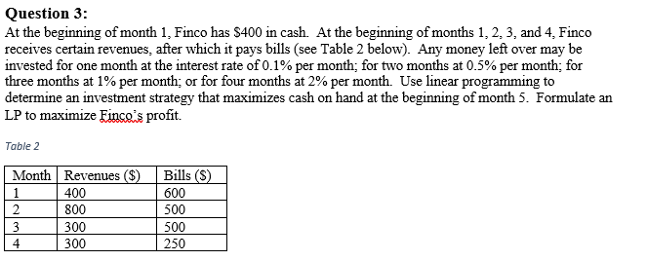

# first number = month when investment started, second number is the number of months the investment lasts

Variables:

* x11
* x12
* x13
* x14
* x21
* x22
* x23
* x31
* x32
* x41

Objective function: # Maximization problem

* Z = 1.001*(x11 + x21 + x31 + x41) + 1.01*(x12 + x22 + x32) + 1.03*(x13 + x23) + 1.08*(x14)

Constraints:

* 400 + 400 - 600 - x11 - x12 - x13 - x14 == 0 # starting cash + rev - bill - month 1s investments = 0
* 1.001*x11 + 800 - 500 - x21 - x22 - x23 == 0 # finsihed invs. + rev - bill - month 2 invs. = 0
* 1.01*x12 + 1.001*x21 + 300 - 500 - x31 - x32 == 0 # finsihed invs. + rev - bill - month 3 invs.
* 1.03*x13 + 1.01*x22 + 1.001*x31 + 300 - 250 - x41 == 0 # finished invs. + rev - bill - month 4 inv.
* xi, xj >= 0

Answer:

* x11 = 200.0
* x12 = 0.0
* x13 = 0.0
* x14 = 0.0
* x21 = 500.2
* x22 = 0.0
* x23 = 0.0
* x31 = 300.7002
* x32 = 0.0
* x41 = 351.0009
* Objective = 1353.2530011

Although this answer may not be correct, this is how I best set up the constraints and objective function

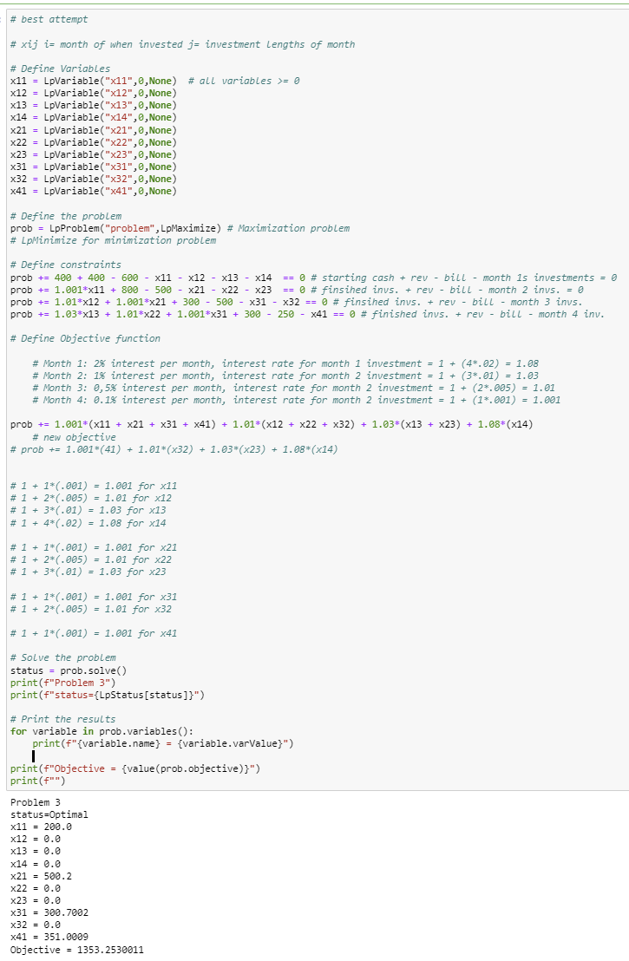

## Problem 4

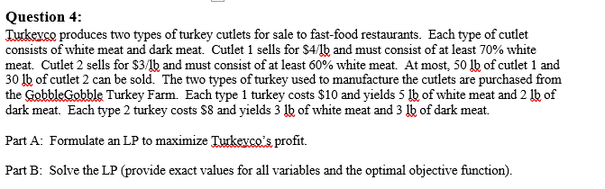

PART A:

W = white meat, D = dark meat, T = Turkey

Variables:

* C1_W
* C1_D
* C2_W
* C2_D
* T1
* T2

Constraints:

* C1_W + C1_D <= 50 # 50lb of cutlet 1 can be sold
* C2_W + C2_D <= 30 # 30lb of cutlet 2 can be sold
* C1_W + C2_W <= 5*T1 + 3*T2 # cost of cutlet 1
* C1_D + C2_D <= 2*T1 + 3*T2 # cost of cutlet 1
* .3*C1_W - .7*C1_D >= 0 # 70% white meat
* .4*C2_W - .6*C2_D >= 0 # 30% white meat
* All variables >= 0

Objective function:

Z = 4*(C1_W + C1_D) + 3*(C2_W + C2_D) - 10*T1 - 8*T2 # Maximization problem

Part B:

**Answer**:

* C1_D = 15.0
* C1_W = 35.0
* C2_D = 12.0
* C2_W = 18.0
* T1 = 8.6666667
* T2 = 3.2222222
* Objective = 177.55555539999997

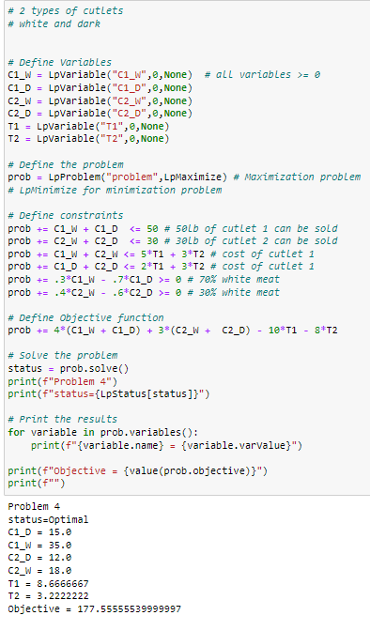

## Problem 5

A company wants to plan production for the ensuing year to minimize the combined cost of production and inventory costs. In each quarter of the year, demand is anticipated to be 130, 160, 250, and 150 units, respectively. The plant can produce a maximum of 200 units each quarter. The product can be manufactured at a cost of $15 per unit during the first quarter, however, the manufacturing cost is expected to rise by $1 per quarter. Excess production can be stored from one quarter to the next at a cost of $1.50 per unit, but the storage facility can hold a maximum of 60 units. How should the production be scheduled so as to minimize the total costs?

Part A: Formulate an LP model to minimize costs.

Q = Quarter, M = Make, S = Storage

* Q1_M
* Q1_S
* Q2_M
* Q2_S
* Q3_M
* Q3_S
* Q4_M
* Q4_S

Constraints:

* Q1_M <= 200
* Q2_M <= 200
* Q3_M <= 200
* Q4_M <= 200

# Max storage is 60 units

* Q1_S <= 60
* Q2_S <= 60
* Q3_S <= 60
* Q4_S <= 60
* # demand per quarter
* Q1_M - Q1_S == 130 # Q1_M - 130 = Q1_S
* Q2_M - Q2_S + Q1_S == 160 # Q2_M - 160 = Q2_S
* Q3_M - Q3_S + Q2_S == 250 # Q3_M - 250 = Q3_S
* Q4_M - Q4_S + Q3_S == 150 # Q4_M - 150 = Q4_S

Objective Function: # Minimization problem

* Q1_M*15 + Q1_S*1.5 + Q2_M*16 + Q2_S*1.5+ Q3_M*17 + + Q3_S*1.5 + Q4_M*18

Part B: Solve the LP (provide exact values for all variables and the optimal objective function).

**Answer**:

* Q1_M = 140.0
* Q1_S = 10.0
* Q2_M = 200.0
* Q2_S = 50.0
* Q3_M = 200.0
* Q3_S = 0.0
* Q4_M = 150.0
* Q4_S = 0.0
* Objective = 11490.0

